IRISH RED AND WHITE SETTER CLUB OF CANADA
NATIONAL SPECIALITY
JUNE 2nd 2012

I was thrilled to receive the invitation to judge this prestigious show and I thank the committee for thinking of me. Also a huge thank you for the hospitality shown to us throughout our stay. My son and I were so very well looked after and greatly enjoyed every minute of our all too short visit to Canada. We met some lovely people and forged what I’m sure will be lasting friendships.
The greatest thanks of course must go to the exhibitors without whom all other efforts would be for nothing. Also thanks to all for the very sporting acceptance of my decisions.
I was very impressed with the overall quality of the entry which compared favourably to any I have seen, including Crufts 2012, however bearing in mind that the perfect dog has yet to be born, I hope the following comments will be taken in the spirit with which they are intended.
As one would expect in any entry, there were examples of several types of constructional fault, but I found nothing in sufficient numbers to be worthy of particular note as a problem for the breed in Canada, although really good hind action was in rather short supply.
I did find several exhibits with lighter than ideal eye colour and whilst this is a purely cosmetic fault it does detract from the desirable soft expression. Also there were several whose coat colour was tending towards orange. Again, along with ticking, a purely cosmetic fault but, whilst always secondary to construction and temperament considerations, these points should not be ignored in breeding programmes.

3 – 6 month Dog
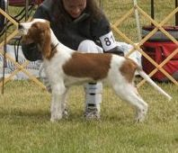
1st Ciesla’s Aislingcudo Brosna Ciarrai,
14 weeks, attractive, well boned pup just right for his age. Promising head, excellent reach of neck fitting smoothly to clean withers. Strong level back, slight slope to croup, very well made hindquarters. A good prospect for the future. Best 3-6month
3 – 6 month Bitch
1st Ua Siaghail’s Aislingcudo Is Eibhlin Mo Croi,
2nd Cenotti’s Aislingcudo Maeve Maltby Lakes,
Not much between these two babies. Litter mates to the dog and much the same remarks apply, I just preferred the head of the 1st at this stage. Congratulations to the breeder on a very even and promising litter. The dog was just a little more forward on the day.

Junior Puppy Dog
Two very nice youngsters here which bodes well for the future of the breed in Canada
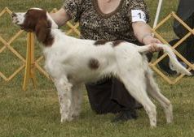
1st Guthrie’s Crossfire Northern Lights
Lovely head on this promising pup. Nicely crested neck, good topline, good angulation and plenty of depth for age. Should have a very bright future. Best Puppy
2nd Flatt’s Whitehot’s Casey McFinnegan
Another promising pup with striking colour and markings. Close up to the winner in all respects but not quite the depth at the moment and needs to tighten a little in front. I marginally prefer the head of the 1st but I’m sure these pups will change places many times in their show careers

12 – 18 month Dog
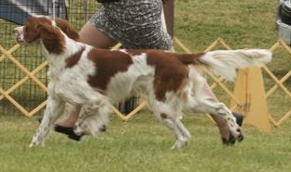
1st Ua Siaghail’s Aislingcudo Is Daly Raithmoir,
Just 12 months old and giving a lot away in maturity but won this class on his construction. Pleasant head but would prefer darker eyes. Good neck, well made forequarters with adequate forechest. Excellent hind angulation and moved with reach and drive.
2nd Perrier’s Aingeal Memories Of KD Live On,
Almost 18 months old, a bigger boy with better colour than the winner. Attractive head of correct proportions, but would prefer darker eyes. Good neck and topline but not the angulation in forequarters of 1st. Moved steadily but not quite the extension I was looking for.

Open Dog
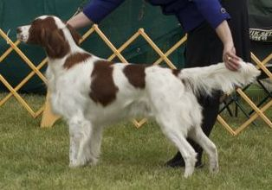
1st Peterson’s and Zawikowski’s Aramis Farms High Road To Killary,
Not a big boy but nicely balanced. Well made forequarters with ample forechest, smooth from neck to shoulders, firm level back and good tailset. Powerful, well angulated hindquarters enabled effortless ground-covering movement. Striking colour and markings. Eyes could be a shade darker and not quite the balance of skull to muzzle I would like but at just 2 years old his head is far from finished. A lot more to come from this top quality young dog. Winners Dog and Best of Winners.
2nd Cenotti’s and Benedetto’s Aislingcudo Mairnealaigh Cle
Prefer the head type of this mature 5 year old. Good reach of neck, pleasing outline and good front assembly. Nice colour and markings. Strode out well enough but going rather close behind today. Reserve Winners Dog.
3rd Osimo’s United Spots Rock Ranger
Upstanding young dog of just over 18 months old. Good eye shape and colour, good balance of skull to muzzle with enough depth to the stop but a little strong in skull and a little too much flew for my taste. Good length of neck and decent front assembly. Not the hind angulation of 1st and 2nd and at this stage of his development just a little short in body making him as tall as he is long. This I am sure will correct as he matures. Strode out with purpose but a little close going away. Very attractive sparkling clear white and rich red.
4th Watson’s Caniscaeli Classic Rock, CGN
A nicely constructed young dog with a good outline. Somewhat narrow and lean all through but at not yet 2 years old there is time for this to improve.
Veteran Dog
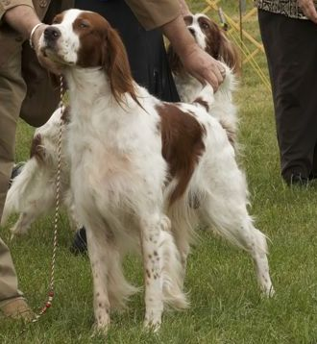
1st Flatt’s Ch Corranroo Chaos, FD
Nothing flashy about this dog, but he is very hard to fault. A good honest dog with a lovely balanced head, good eye shape and colour, very well made all through with a beautifully straight front, well laid shoulders and good return of upper arm, strong level back, correct tail set and well angulated hindquarters. At almost 10 years old this dog moved out strong and true showing the youngsters how it should be done. Best Veteran
2nd Guthrie’s Ch Crossfire Johnny Appleseed,
Most attractive and eye-catching 7 year old. Top size but everything in total balance, beautiful head with lovely soft expression, well constructed throughout and in excellent clear white and rich red coat. Sadly he just did not want to move which was a pity.
3rd Guthrie’s Ch Taniswood Time Will Tell,
Loved the head on this most appealing almost 12 year old. Well made and must have been a very good dog in his day. Did his best on the move, obviously enjoying his day out. What a sweetheart!
12 – 18 month Bitch
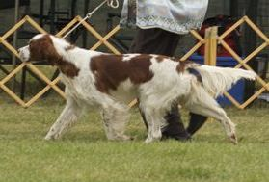
1st Guthrie’s Crossfire Catch The Thrill,
Lovely shape to this very pretty 13 months girl. Well boned, good length of neck into well laid shoulders, firm level back, well angulated fore and aft. Needs to settle to the job in hand but she has great potential. I liked her a lot.
2nd Benedetto’s Aislingcudo Mairnealaigh Dea,
Well schooled young lady of 14 months. Clean lines, firm topline and adequate angulation. Lighter boned than 1st and rangier at this stage but should develop on nicely. Moved out well.

Open Bitch
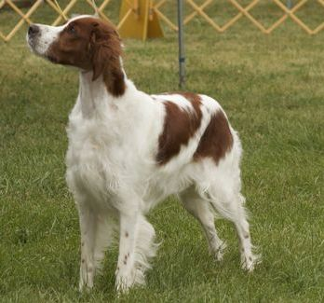
1st Logan’s Aislingcudo Is Einin Ar Gcroi,
Eye-catching, bitch with a lovely outline. Very pretty head of correct proportions, good reach of neck fitting smoothly at the withers, strong level back, correct tailset, adequate balanced angulation. Moved well in profile but a little close behind. Winners Bitch.
2nd Osimo’s Moonstone Red Elle,
Strikingly marked bitch with sparkling clear white and rich red coat. Nice outline with adequate angulation but could be tighter at the elbows, pleasing head shape but a little light in eye. Moved out well. Reserve Winners Bitch
3rd Ringelberg’s Crossfire Shining Star,
Lovely type of bitch who I’m sure could do very well in the show ring if schooled to the job. Sadly she would not co-operate to be assessed so had to pay the price.
Veteran Bitch
A very close decision here between these two distinguished ladies, both very worthy title holders.
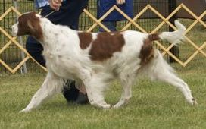
1st Guthrie’s Ch Crossfire Dancing In My Dreams,
Marginally preferred the head of this lovely 7 year old who scored in front angulation, forechest and her lovely profile movement.
2nd Flatt’s Ch Whitehot’s Hilda Daisy,
Also lovely, this quality 8 year old scored in topline, well placed elbows and strong pasterns. Not showing quite the extension on the move which was the deciding factor.

Specials Only
A pleasure and a privilege to judge this group of champions, each one a worthy title holder.
Best of Breed
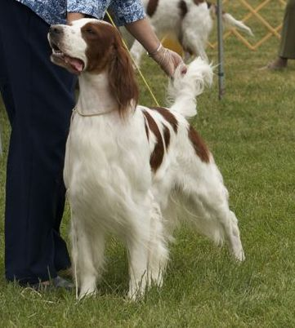
Harrison’s Ch Shireoak Caniscaeli Windsong CGN
For me this lovely dog is the epitome of the breed standard. There is nothing either over or underdone. He is balanced skull to muzzle with just the right depth of stop and correct round dark eyes giving a kind and gentle expression. His head is perfectly balanced to his body which in turn is balanced front to back with correct angulation. He is clean throated, has ample forechest and a good length of neck, smooth over the withers, well sprung ribs, level back, strong loin and correct tailset. He is strong and powerful without a hint of coarseness and moved like a train with great reach and drive. Lovely colour and markings complete the picture. One of the very best I have seen in my 30 years of involvement with this wonderful breed.
Best of Opposite Sex
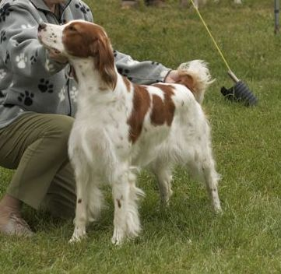
Riedel’s and Flatt’s Ch Whitehot’s Six Of One,
A lovely quality bitch showing just the right balance of strength and substance to femininity. She has a lovely head and expression, good bone and excellent conformation giving an excellent outline. One I would be very happy to own.

Award of Merit
Taylor’s Ch Shireoak Spring Frost FDJ,
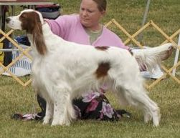
Another outstanding dog from this affix and much the same remarks apply, but just a little rangier and not quite the substance of my B of B . Most beautiful head and expression. Loved him.
Best Brace
Guthrie’s Ch Crossfire Dancing In My Dreams and Ch Crossfire Rising Star
Best Stud Dog
Guthrie’s Ch Taniswood Time Will Tell
Best Brood Bitch
Guthrie’s Ch Crossfire Dancing In My Dreams
Best Three Generations
Ch Corranroo Chaos; Ch Clancuddy Aragorn Of Dunedain; Whitehot’s Casey McFinnegan

Jackie Howatson (Judge)
Photos courtesy of Dom Cenotti

